**Exercise 1: Implementing the Singleton Pattern**

* 1. **Code:**

**Logger.java:**

public class Logger {

private static Logger *instance*;  
  
 private Logger() {  
 System.*out*.println("Logger instance created.");  
 }  
 public static Logger getInstance() {  
 if (*instance* == null) {  
 *instance* = new Logger();  
 }  
 return *instance*;  
 }  
 public void log(String message) {  
 System.*out*.println("Log message: " + message);  
 }  
}

**SingletonTest.java**

public class SingletonTest {  
 public static void main(String[] args) {  
  
  
 Logger logger1 = Logger.*getInstance*();  
 logger1.log("First log message");  
  
 Logger logger2 = Logger.*getInstance*();  
 logger2.log("Second log message");  
  
 if (logger1 == logger2) {  
 System.*out*.println("Both logger instances are the same.");  
 } else {  
 System.*out*.println("Logger instances are different!");  
 }  
 }  
}

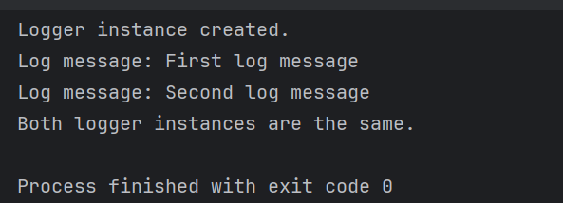**1.2 Output:**

**Exercise 2: Implementing the Factory Method Pattern**

**2.1 Code:**

**FactoryMethodExample.java**

public class FactoryMethodExample {  
 interface Document {  
 void open();  
 }  
 static class WordDocument implements Document {  
 public void open() {  
 System.*out*.println("Opening Word document...");  
 }  
 }  
 static class PdfDocument implements Document {  
 public void open() {  
 System.*out*.println("Opening PDF document...");  
 }  
 }  
 static class ExcelDocument implements Document {  
 public void open() {  
 System.*out*.println("Opening Excel document...");  
 }  
 }  
 static abstract class DocumentFactory {  
 public abstract Document createDocument();  
 }  
 static class WordDocumentFactory extends DocumentFactory {  
 public Document createDocument() {  
 return new WordDocument();  
 }  
 }  
 static class PdfDocumentFactory extends DocumentFactory {  
 public Document createDocument() {  
 return new PdfDocument();  
 }  
 }  
 static class ExcelDocumentFactory extends DocumentFactory {  
 public Document createDocument() {  
 return new ExcelDocument();  
 }  
 }

public static void main(String[] args) {  
 DocumentFactory factory;  
  
 factory = new WordDocumentFactory();  
 Document word = factory.createDocument();  
 word.open();  
  
 factory = new PdfDocumentFactory();  
 Document pdf = factory.createDocument();  
 pdf.open();  
  
 factory = new ExcelDocumentFactory();  
 Document excel = factory.createDocument();  
 excel.open();  
 }  
}

**2.2 Output:**

